X2go client can be downloaded from ( it is installed on the morgan state cloud – Bear general VM)
Download link

Instructions for setting X2Go for your account
- Start up the X2Go client
- Name the Session ( a good idea is to name the session the name of the server)
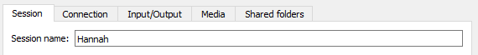

- Enter the host IP and Login ( username), leave the SSH as 22
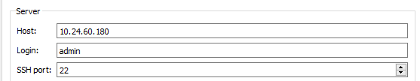

- Change session type to XFCE
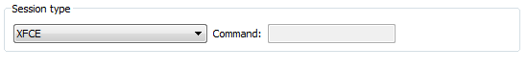
- Change connection to LAN
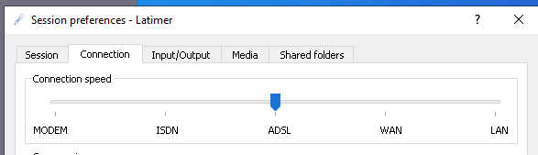

- You can resize the screen to your optimal resolution
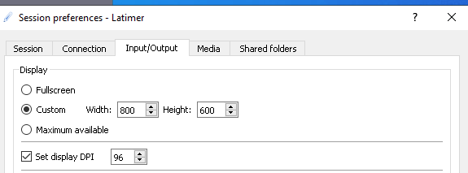

- Click on OK

- Click on the server name on the right hand side and enter your password at the prompt.
